Website review
I will go through the website in this order
About us page
- Are the tabs meant to “go” anywhere as they can be hovered over but clicking them doesn’t do anything.

- “Find an experienced agent who knows your market best” should read “An experienced agent who knows your market best”

- “Homes, flats & apartments in the places you love” change to “Properties in place you love”

- “As trusted Wolverhampton estate agents, our focus is on strong communication and achieving the right outcome for every client.” Change to “As trusted estate agents in the West Midlands, our focus is on strong communication and achieving the right outcome for every client.”

- “Trusted by Thousands of Clients” – change to “Trusted by our clients”

FAQs
- What areas do you cover – please change to “Which areas do you cover?”

Buying page

- Can we get rid of this, not sure what it was meant to say but as it’s the selling page, we don’t need it there.

- Property addresses aren’t showing properly.

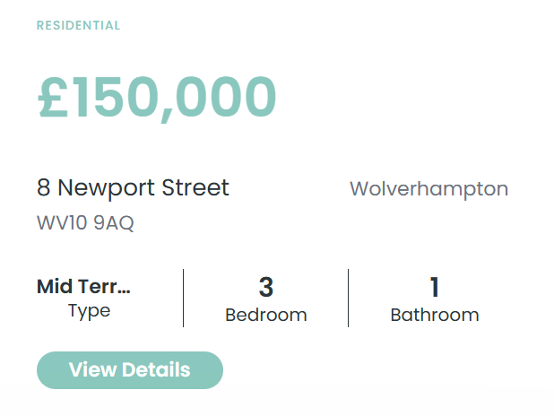

- Wolverhampton should be beneath 8 Newport Street, this goes for other property addresses as well.
- Also, where it shows the type of property
- Property type in the search tab does not match the property type on the descriptions

- Each property has a different amount of details available or some details duplicated – can you check why this is? Where is the information pulled from and does that impact it?

- On property details, the rents and charges are shown in dollars – can this be changed to pound sign.

- On property details, where there are numbers representing a value, there is other information there ahead of the details. See image below taken from St Johns Walk:
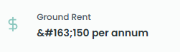
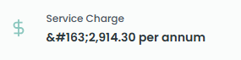

FAQs
- Under the first heading can we change from this: We list a wide range of property for sale across the West Midlands, including detached and semi-detached houses, terraced homes, flats, bungalows and new-build developments. Our houses for sale in Wolverhampton and Willenhall cater to first-time buyers, growing families and seasoned investors alike – to this – “We list a wide range of property for sale across the West Midlands, including detached and semi-detached houses, terraced homes, flats, bungalows and new-build developments. Our houses for sale cater to first-time buyers, growing families and seasoned investors alike.”

- Under the 3rd heading relating to mortgages: can we add the following line:

We can also recommend experienced, qualified solicitors who specialise in residential property transactions to guide you through the legal process of buying or selling a home.

- Stay updated and unlock exclusive perks – can we remove this as we don’t have any such scheme at the moment

